~Asia-China-Mirror-Yuan Dynasty-Bloom And Bird Pattern Bronze Mirror

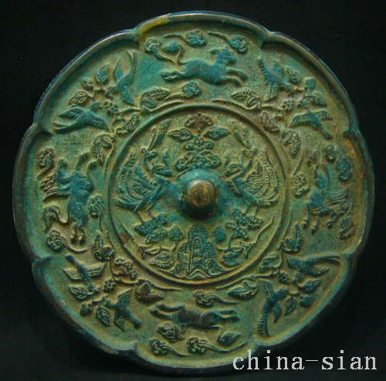
Diameter 141 mm Deep 4.5 mm

